Changing Pay/Tax Statements back to Paper
Confirming/Adding Personal Cell/Email
To ensure that you receive a paper copy of your last pay check and W2, and that you are able to receive notifications to reset your password, please complete the below steps before your last day.
- Log into ADP
- Click on Myself
- Click on Pay
- Click on Pay and Tax Statements
  - Scroll down to Go Paperless
  - Click on the Go Paperless Icon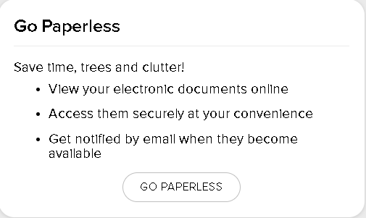
- Check the icons on the right, for both Pay Statements and Tax Statements and if they are “On” Click each one to “Off”

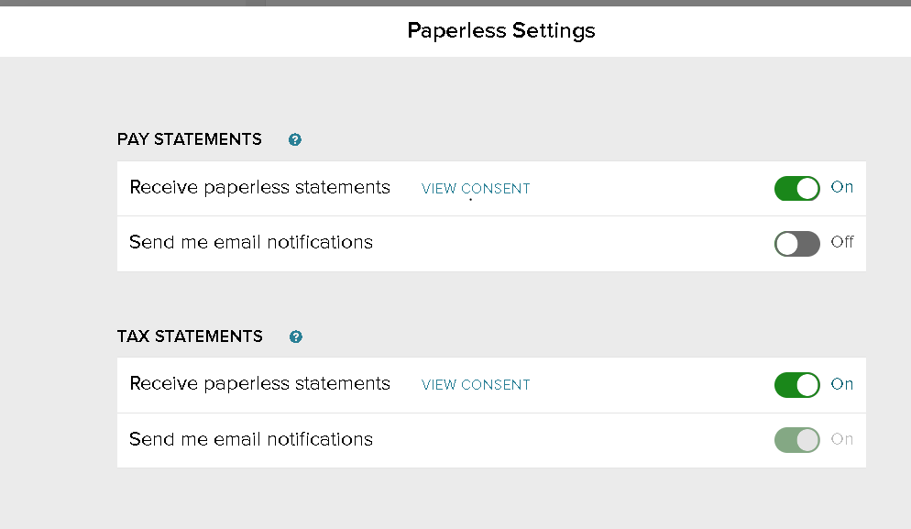

Notification Information: (This is the information used to reset a password)
- Go to Myself
- My Information
- Profile
  - Personal Information
  - Make sure your personal cell and email are entered
- Click on View More
  - If your cell and email are not entered add it now
  - If they are already entered scroll down to Contact at the bottom
  - Make sure your number is Verified and that Yes is checked
